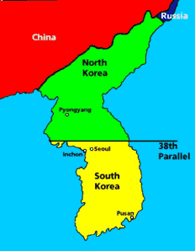
The Korean War
Overview: The Korean War was the time when the Cold War became a global conflict. In 1945, Korea was freed from the Japanese. US troops stayed in South Korea and Soviet troops remained in North Korea. The country was split in half at the ____________________________:
- North Korea (led by ____________________) was ____________________________.
- South Korea (led by ____________________) was ____________________________.

What Caused the Korean War?
Directions: Take a look at the timeline of events below. Then, make a hypothesis to answer the question from the point of view of the United States government.
1947 -
- “We have drawn the line in Korea meaning containment of Russian influence had to be applied into Korea.”
-Dean Acheson, Undersecretary of State in a secret hearing, 1947
- “Japan and Korea are the areas outside Europe requiring large-scale economic assistance.”
-George Kennan, the head of Policy Planning Staff, June 1947
- Marshall Plan -June 5, 1947

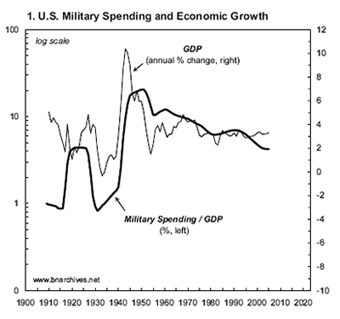
1949 -
- Final withdrawal of U.S. troops from South Korea. - June 30, 1949
- Soviet Union conducts a successful nuclear test. - September, 1949
- Chinese Communists win their Civil War. - December, 1949
- During the first 5 months of 1950, the Russians gave the North Koreans an offensive force-tactical aircraft, armor, trucks, and artillery. - January-May, 1950
- President Truman requested a complete review and re-evaluation of America’s Cold War diplomacy strategy. The result was NSC-68, a report that was completed in April 1950. - April, 1950
- In April 1950, the American National Security Council issued a report (______________________) recommending the U.S. should vigorously pursue a policy of “containing” Soviet expansion.

Your Hypothesis: ___________________________________________________________________________________
____________________________________________________________________________________________________________________________________________________________________________________________________

The ___________________________________ would govern much of U.S. foreign policy from the 1950s-1980s. Many believed that if one country fell to Communism, then others would follow, like a line of dominoes. While this term wasn’t actually used until 1954, at this point Truman and others were worried that, if Korea fell, the Communists would capture Japan.
Task: Using 6 words, describe the domino theory.
___________ ___________ ___________ ___________ ___________ ___________
ANALYZE THIS QUOTE:
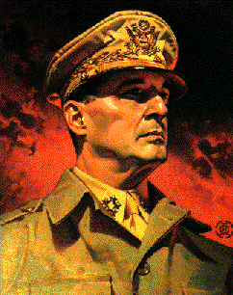
“Asia is where the communist conspirators have decided to make their play for global conquest. If we lose this war, the fall of Europe is inevitable. There is no choice but victory.”
- US General MacArthur, speaking in 1950
Task: Explain why General MacArthur thinks Korea is so important for the Americans.

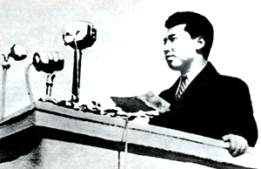
Kim II Sung Gets Support
In 1949, he persuaded Stalin that he could conquer South Korea. Stalin did not think that America would dare to get involved, so he gave his agreement. Stalin saw a chance to continue the cold war and discomfort America, but ‘at arm’s length’ – _____________________________________________________ the Americans. Kim II Sung also went to see _________________________________, the leader of China, to get his agreement.

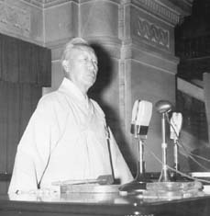
Syngman Rhee Also Boasts
In an interview with United Press, in October, 1949, Syngman Rhee boasted that the South Korean army could take the North Korean capital of Pyongyang within three days. On November 1st, the New York Herald Tribune reported that the South Korean War Minister had declared that his army was ready and waiting to push into North Korea. It was a good
enough excuse – on June 25, 1950 the North Koreans invaded South Korea.
…and so began the war….

TASK: Before we continue on, you must rank the main causes of the Korean War. Starting with #1 being the most important cause, compile your list. Include a brief explanation to support your choices.

- ___________________________________________________________________________________________
- ___________________________________________________________________________________________
- ___________________________________________________________________________________________
- ___________________________________________________________________________________________
- ___________________________________________________________________________________________

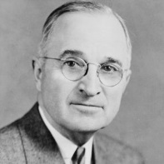
EXAMINING TWO VIEWPOINTS:
A Police Action - The President's News Conference, June 29, 1950
11.] Q. Mr. President, could you elaborate on this statement that--I believe the direct quote was, "We are not at war." And could we use that quote in quotes?
THE PRESIDENT. Yes, I will allow you to use that. We are not at war.
Q. Could you elaborate sir, a little more on the reason for this move, and the peace angle on it?
THE PRESIDENT. The Republic of Korea was set up with the United Nations help. It is a recognized government by the members of the United Nations. It was unlawfully attacked by a bunch of bandits which are neighbors of North Korea. The United Nations Security Council held a meeting and passed on the situation and asked the members to go to the relief of the Korean Republic. And the members of the United Nations are going to the relief of the Korean Republic to suppress a bandit raid on the Republic of Korea.
Q. Mr. President, would it be correct, against your explanation, to call this a police action under the United Nations?
THE PRESIDENT. Yes. That is exactly what it amounts to.

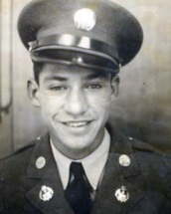
Why Are We Here?
19 year old first class Private James J. Lutze - 5th Cav. Regiment. Excerpts of a letter to his mother.
"The question on the lips of the G.I. over here is, "What are we fighting for?” This is no 'police job' as Mr. Truman says. It is a real war, but not the kind most people at home can realize. We are fighting men who can live for a week in the mountains with just a little bag of rice. Where we have to travel by road they travel over the mountains and beat us to where we are going. We attacked and took a small town the other day with no opposition at all. Then, just before daylight, a couple days later, they hit us with everything they had, and we were forced to withdraw for about eight miles with heavy casualties. About half the members of our battalion have been killed or wounded. Among the latter is our battalion commander and six other officers including my section leader.......
"Well, we withdrew again last night for about 10 miles and again the enemy knew we were moving, because they shelled the road. It's an old saying here on the lines that if you kill one Korean, there are 10 more to takes his place.......In closing all I can say is this: give us reinforcements, or pull out what is left of us---which isn't many.“
- Summarize and explain how Truman refers to the situation in Korea.

- Identify and discuss the point of view of President Truman.

- Summarize and explain how it seems the war is being fought in Korea based on Lutze’s account.

- Identify and discuss the point of view of Private James J. Lutze.

- Craft a comparative thesis statement based on the viewpoints in these two passages. Analyze the similarities and
differences in their views of the Korean War.
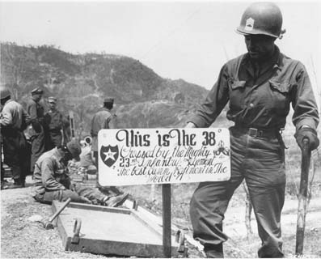
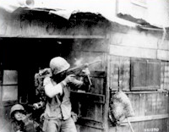
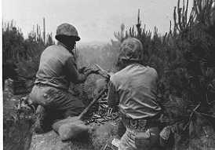

The Events Of The War
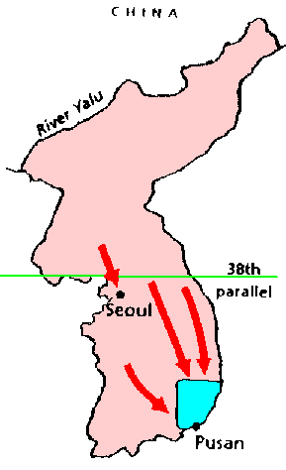
June, 1950 – North Korea Invades South Korea; Truman Commits US Forces.
- The North Koreans attacked. They were very successful. The __________________________
______________________ (NKPA) easily defeated the _______________________________
army (the ROKs).
- They captured most of South Korea, including the capital of ____________________.
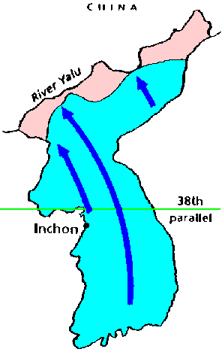
- The Americans were alarmed and they persuaded the United Nations to support South Korea.
Out of the 300,000 UN troops, 260,000 were Americans.

September 15, 1950 – UN Makes Daring Landing At ____________
- The American army, led by _______________________________, went to Korea. It landed at Pusan, and made an amphibious landing at Inchon (near Seoul).

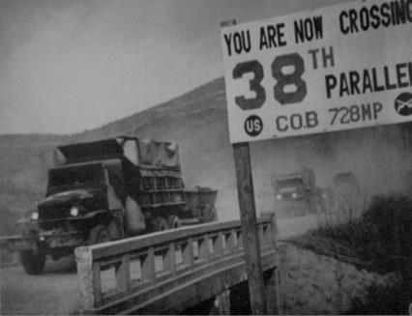
- It drove back the North Koreans and recaptured South Korea. 125,000 NKPA prisoners were taken.

October 1, 1950 – South Korean Troops Cross At The 38th Parallel
- South Korean troops cross the 38th Parallel and enter North Korea.
Task: Evaluate the UN decision to cross into North Korea after successfully recapturing South Korea. List the potential positives and negatives of this action?
_{POSITIVES} | _{NEGATIVES}

Ultimate goal of this action: _________________________________________________________________________
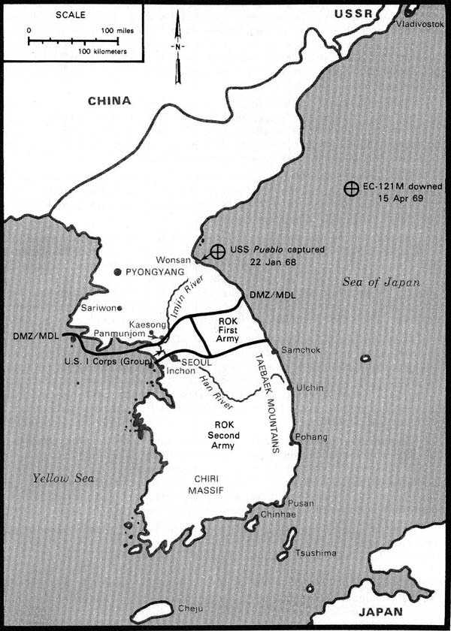
Map Interpretation:
Based on this map, why do you think President Truman warned
MacArthur to keep the UN forces at least 40 miles from the Yalu River?
___________________________________________________________
___________________________________________________________
___________________________________________________________
October 26, 1950 – UN Forces Reach Yalu River
- North Korea’s capital, _______________________, fell to UN troops on October 20th.
- By October 26th, the first UN troops had reached the _____________________. – the border between China and North Korea.
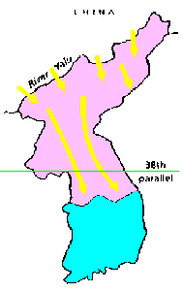
November 1950, Massive Chinese Attack Across The Yalu River
- _____________________________ ('People's Volunteers') attacked MacArthur. They had
modern weapons supplied by the Soviet Union, and a fanatical hatred of the Americans.
- In December, half a million more Chinese troops entered the war.
- They drove the Americans back. They recaptured North Korea, and advanced into South
Korea.
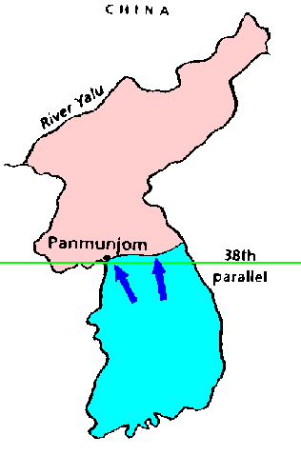
February – March 1951: Stalemate
- The Americans landed more troops. They used bombers. The Chinese admitted to losing 390,000 men dead - UN sources put the figure at up a million Chinese and half a million North Koreans dead.
- The Americans drove the Chinese back, but lost ________________________ American soldiers doing so.
- MacArthur reached the 38th parallel in March 1951.

March 1951 - President Harry Truman vs. General Douglas MacArthur
- MacArthur declares "There is no substitute for victory." He wants to push further. He claimed that the only way to bring about victory was by taking the war to China.
- In a message to House Republican leader, MacArthur expressed his frustration with the limited war the U.S. was fighting against communists. He publicly criticized Truman’s decisions.
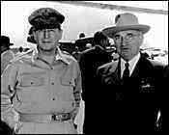
Truman vs. MacArthur
Who Was Right? – You Decide
Should President Truman have relieved General MacArthur? Who better understood the situation? Would MacArthur's policies have ended the war in Korea sooner, or would they have risked World War III?
Do you think President Truman was right or wrong in dismissing Gen. MacArthur? Explain your answer.
__________________________________________________________________________________________________________________________________________________________________________________________________________________________________________________________________________________________________________________________________________________________________________________________________________________________________________________________________________________________________________
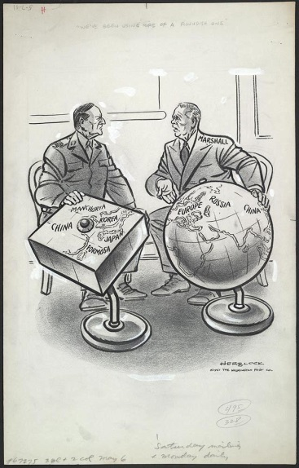
Explain the meaning of Defense Secretary George
Marshall’s statement.
______________________________________________________
______________________________________________________
______________________________________________________
______________________________________________________
"We've been using more of a roundish one"

July, 1951 - ___________________ begin as both sides continue fighting.

July 27, 1953 – Truce Ends Korean Fighting; 38th Parallel Is Truce Line
- In July 1953 an ____________________, or truce, was agreed upon.
- designed to "insure a complete cessation of hostilities and of all acts of armed force in Korea until a final peaceful settlement is achieved."
- Korea was to remain divided at the 38th parallel.
- Tension still existed on either side of the _______________________________ (DMZ), a neutral area in which no warfare could be waged.
Results of the Korean War
- It cost the United States 54,000 dead and 103,000 wounded.
- Total UN casualties reached about 400,000 dead or wounded.
- South Korea suffered close to a million civilian casualties, with several million made homeless.
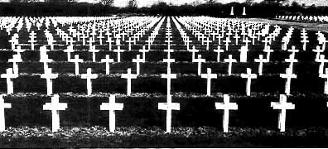
- Nearly 1½ million North Korean and Chinese soldiers were dead or wounded.

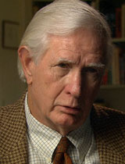
Returning Home
Some 54 years after the war, John Martin Meek, a former US Navy Corpsman, recalls the hurt of coming home in his uniform and being treated like an outcast. "…[I]n World War II…everybody who came home was treated like a hero…and I came home and people were looking at me like I was some kind of freak…and two or three of them said, what are you doing in that uniform? It still stuns me."
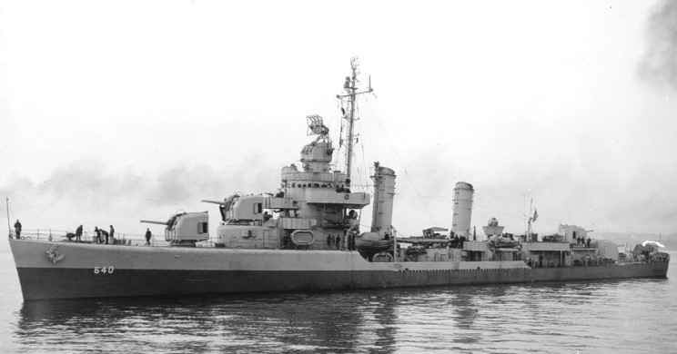
Vincent Walsh, a former machinist crewmate on the destroyer USS. Beatty, also harbors bitter memories about returning home from the war: "…[N]obody seemed to know we'd ever been there…People didn't care about the war. They weren't thinking about it. They just put it out of their minds. The attitude was, you were a sucker. The guys that stayed home got all the good jobs."
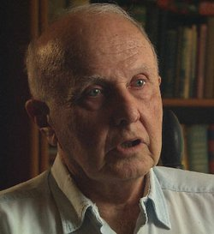
As veteran Spencer Titley from the United States Army recalls, “I know no great novel written about it. And there is no poetry written. No songs. Nothing on the culture side marks the passage of Korea. It was basically over and done with and forgotten.”

Describe the overall tone of these veterans. Explain.

- Why do you think this conflict has the nickname “The Forgotten War?”

- Those who fought and died should not be forgotten. Create a new nickname for the Korean War.

